Strings in Java

Assignment

Question 1- What is Mutable String in Java Explain with an example

Ans-

Strings are immutable, which means that their values cannot be changed after they are created. However, the StringBuilder and StringBuffer classes provide mutable strings, which can be modified after they are created.

Here is an example of using StringBuilder to create a mutable string:

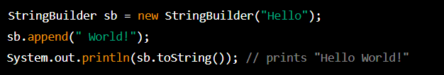

In this example, we create a StringBuilder object with the initial value “Hello”. We then append the string “Word!” to the end of the StringBuilder using the ‘append’ method. Finally, we print the resulting string using the ‘toString” method. Since StringBuilder is mutable the value of ‘sb’ has been changed to “Hello World!” after the ‘append’ method is called.

Question 2- Write a program to reverse a string

Input :“PWSKILLS”

Output: “SLLIKSPW”

Ans-

Program to reverse a string:

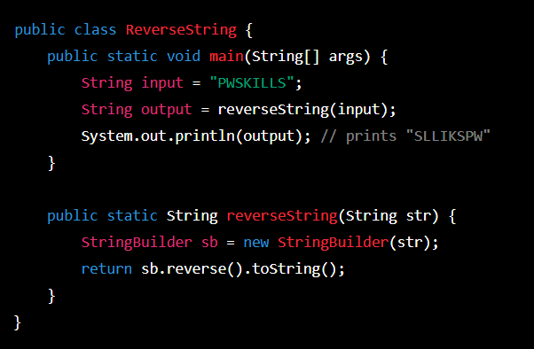

In this program, we define a ‘reverseString()’ method that takes a string as input and returns its reversed version. We use a ‘StringBuilder’ to create a mutable string object, then use its ‘reverse()’ method to reverse the characters in the string. Finally, we convert the ‘StringBuilder’ back to a string using the ‘tostring()’ method and return it.

In the ‘main()’ method, we call ‘reverseString()’ with the input string “PSKILLS” and print the resulting output, which should be “SLLIKSPW”.

Question 3- Write a program to reverse a sentence while preserving the position

Input:THINK TWICE

Output:”Kniht eciwt”

Ans-

Program to reverse a sentence while preserving the position of each character:

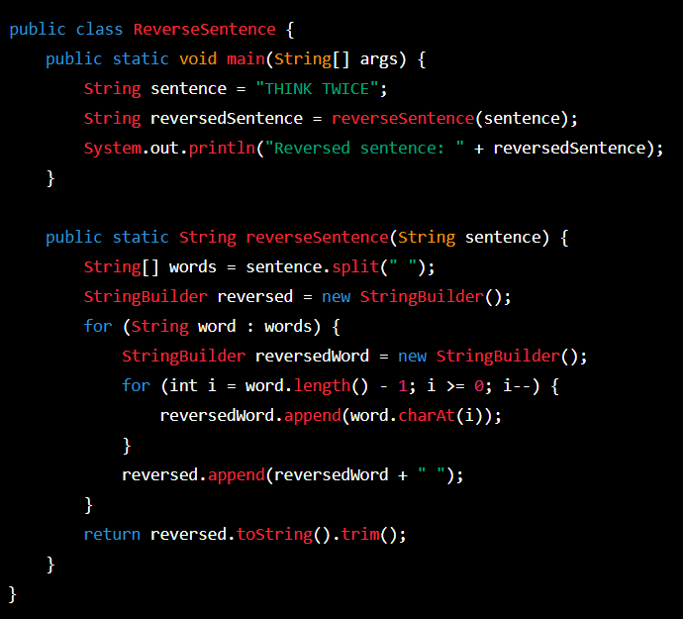

Question 4- Write a program to sort a string Alphabetically

Ans-

An example of program to sort a string alphabetically:

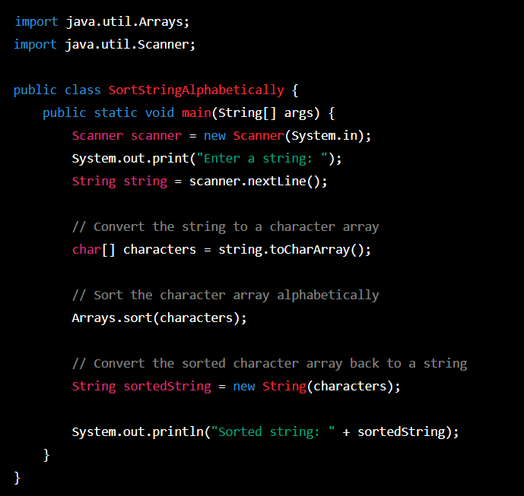

In this program,we use the ‘scanner’ class to read a string from the user. We then convert the string to a character array using the ‘toCharArray()’ method. We sort the character array using the ‘Arrays.sort()’ method, which sorts the elements in ascending order. Finally, we convert the sorted character array back to a string using the ‘String’ constructor that takes a character array as an argument. The sorted string is then printed to the console.